**Exp. 12 Installing a type 2 Hypervisor using VMware**

**Aim:**

To demonstrate virtualization by Installing Type-2 Hypervisor in your device, create and configure VM image with a Host Operating system (Either Windows/Linux), using VMware workstation.

**Procedure:**

* Open VMware workstation
* Click on create new VM and then select Typical(recommended)
* Select the ISO file of the required OS
* Enter the required VM details
* Set hard disk size
* Then finish the setup and install the OS

**Output:**

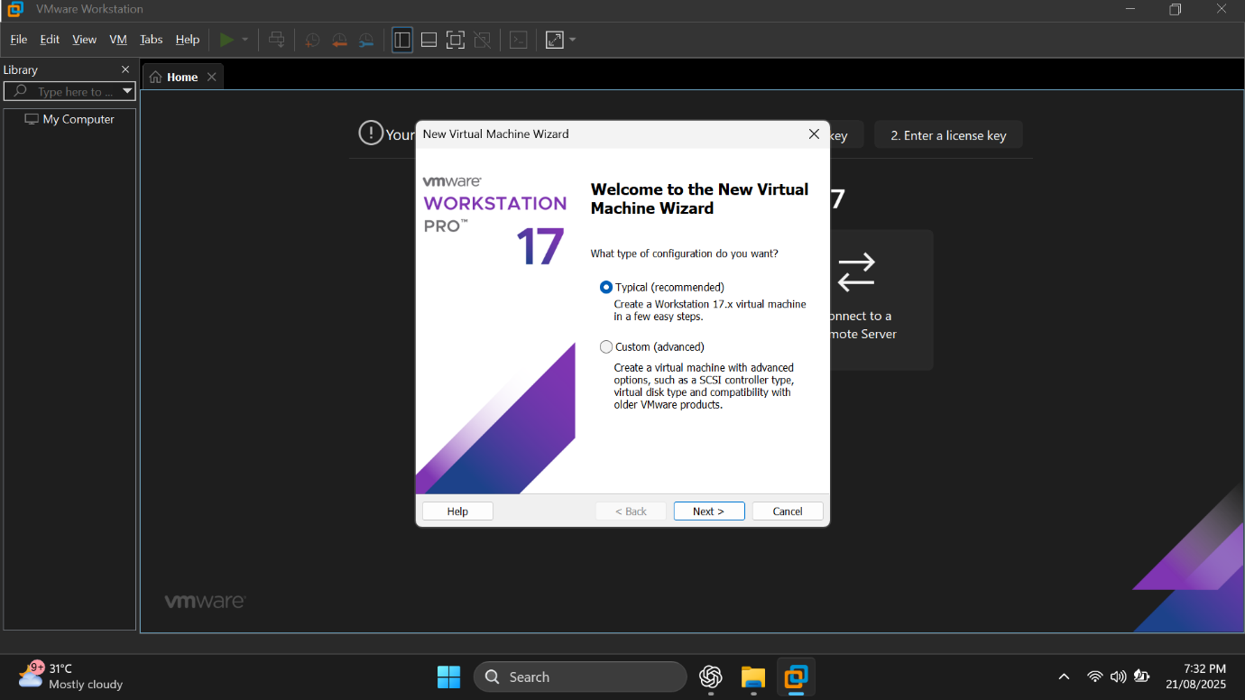

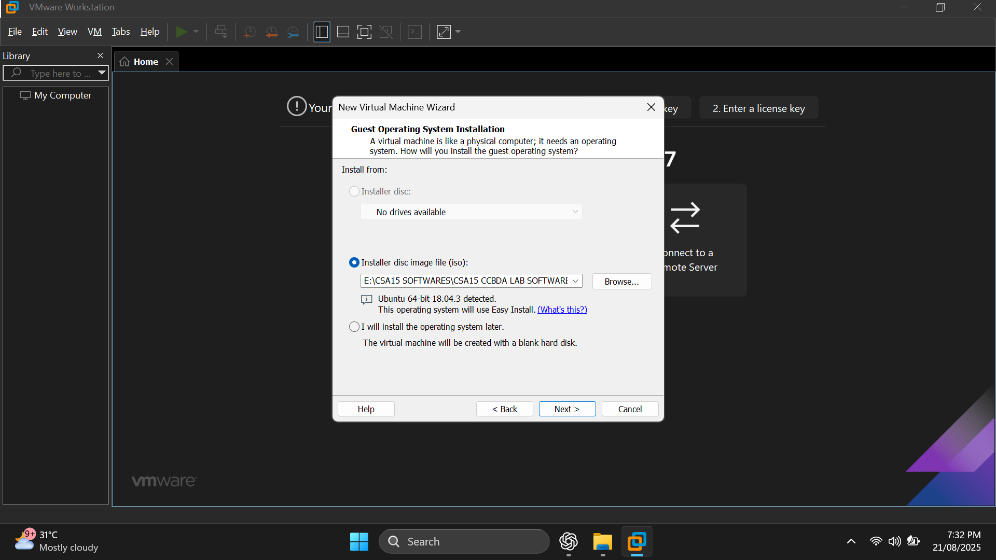

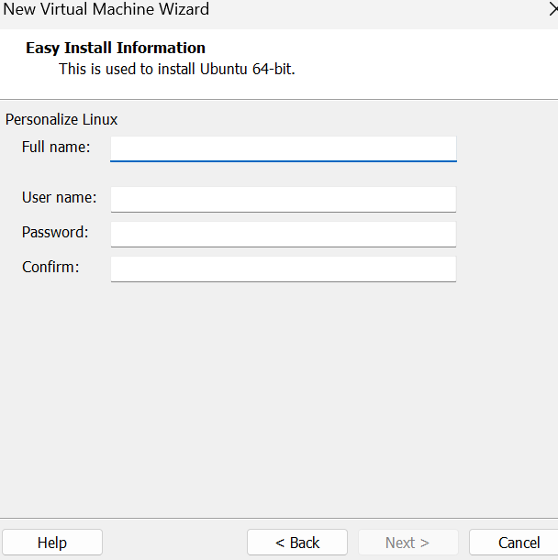

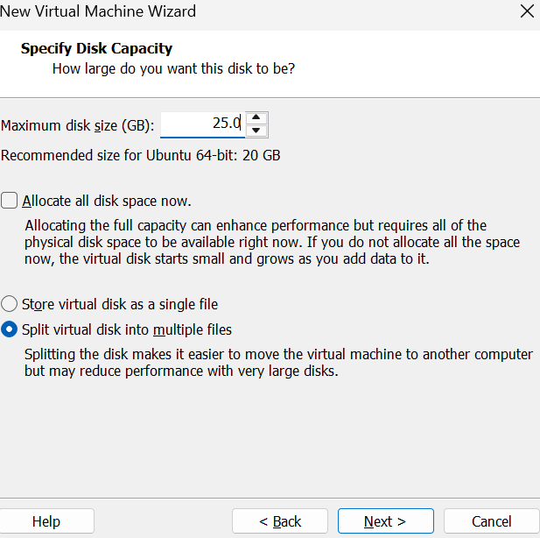

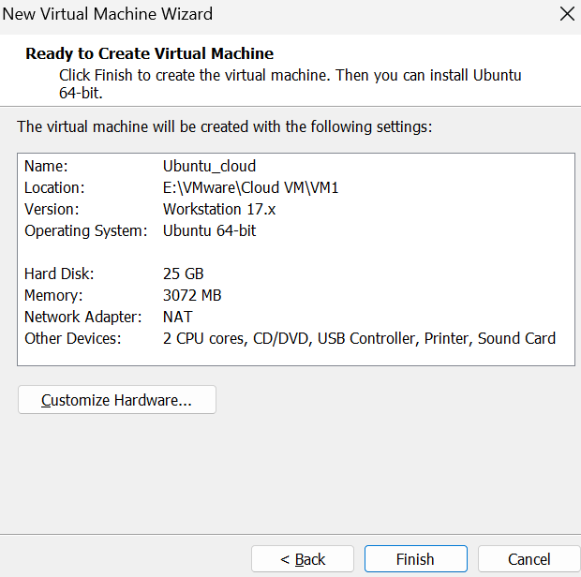

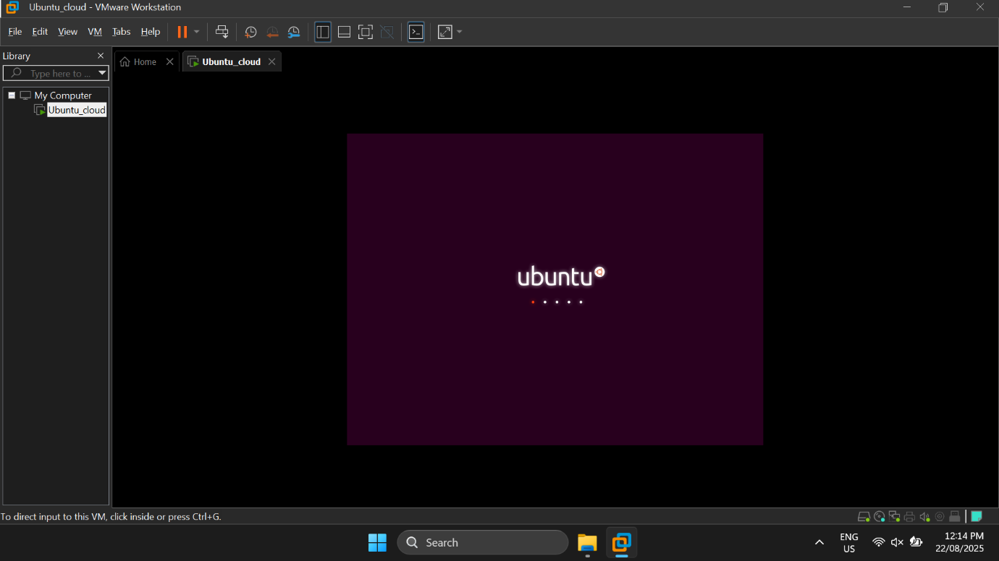

**Result:**

Thus the VM was created and run successfully